Laboratory work 4

1.a) What are the main phases in the database design? What is done on each development phase?

Initial phase --characterize fully the data needs of the prospective database users.

Second phase -- choosing a data model

•Applying the concepts of the chosen data model

•Translating these requirements into a conceptual schema of the database.

•A fully developed conceptual schema indicates the functional requirements of the enterprise.

▪Describe the kinds of operations (or transactions) that will be performed on the data.

Final Phase --Moving from an abstract data model to the implementation of the database

•Logical Design –Deciding on the database schema.

•Physical Design –Deciding on the physical layout of the database

a) What is the entity-relationship (ER) data model?

An entity relationship diagram (ERD), also known as an entity relationship model, is a graphical representation that **depicts relationships among people, objects, places, concepts, or events within an** information technology (IT) system.

2.a) Create entity “Student” with at least 5 attributes (One for each type of attribute: simple, composite, derived, multivalued)

b) Create entities “University”, “Course”, “Dormitory”, “Teacher”, “Office of the Registrar” with at least 3 attributes each. (Entity types should be correct on data model)

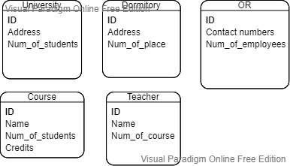

3.Give examples for one-to-many, one-to-one, many-to-many, many-to-one relations. (Draw the examples as a scheme)

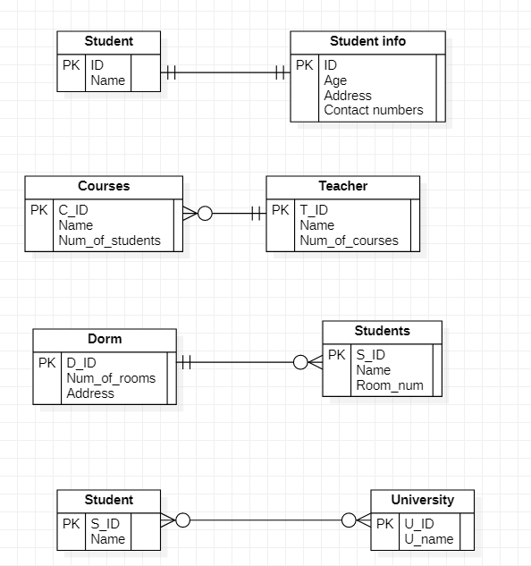

4.Create ER data model with relations using data from the second task.

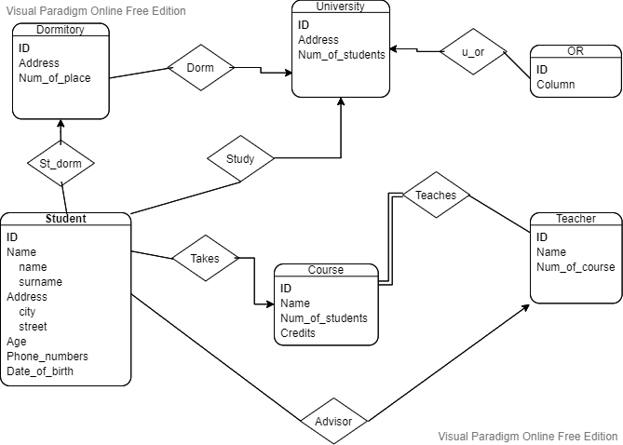

5.Create ER data model for IT company. (At least 5 entities and 8 relations)

